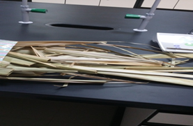

Waste of palm fronds

Physical treatment

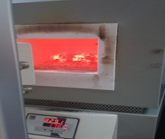

Mathematical model

$${ C}_{{HM}_{1}}=-\left[ K_{ads,1}^{+} C_{T }K_{srp}^{*}- C_{T}K_{ads,1}^{-} \right]t+C_{HMi}$$

Mechanical treatment

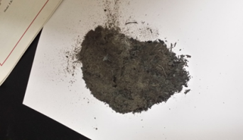

$${ r}_{d}= K_{Srp,1}^{+}[ C_{{HM}_{1}.Sr}- \frac{P_{A_{1}}C_{V}}{K_{Srp}^{*}} ]$$

$$r_{ad}= K_{ads,1}^{+} [ P_{{HM}_{1} }C_{V}- \frac{C_{{HM}_{1}.Sr}}{K_{ads}^{*}} ]$$

Chemical treatment

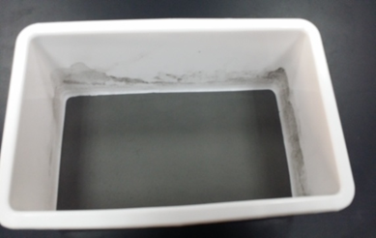 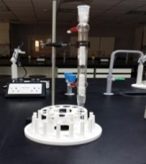 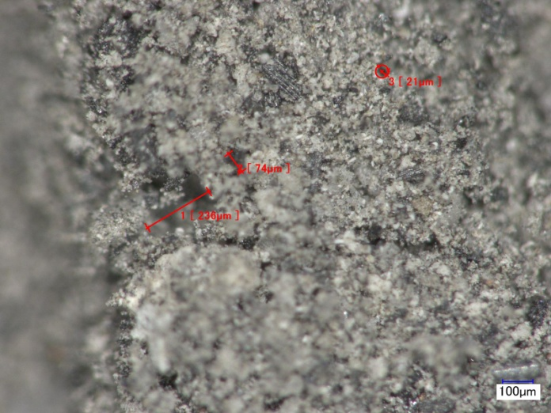

Multi fixed bed

**Figure** 1 Shows the illustrate of waste water treatment using palm fronds**.**